week 3.23 zichao
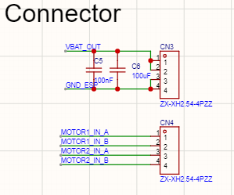
Week 2: Motor Power and PWM Control Interconnect
1. Functional Overview
This schematic section highlights the Motor Power and Signal Connectors (CN3, CN4), which form the critical bridge for high-current power and PWM control logic. By separating the power supply and logic signals into distinct connector blocks, the design minimizes cross-talk and ensures that the large currents required by the motors do not interfere with the sensitive PWM timing signals sent from the ESP32-S3.
2. Design Rationale
- Dedicated Motor Power Rail (CN3):
  - CN3 is dedicated to the VBAT_OUT supply, providing the primary energy source for the motors.
  - Bulk Decoupling: The inclusion of C6 (100uF) and C5 (100nF) is essential for a dual-PCB robotics system. The 100uF electrolytic capacitor acts as a local energy reservoir to handle the high inrush current when the motors start or reverse, preventing a sudden voltage drop that could reset the MCU. The 100nF capacitor filters out high-frequency noise generated by the motor's internal brushes.
- PWM Logic Interface (CN4):
  - CN4 carries the four logic signals (MOTOR1_IN_A/B, MOTOR2_IN_A/B) required to drive the TC118S H-bridge drivers.
  - These signals are standard Pulse Width Modulation (PWM) outputs from the ESP32-S3, allowing for precise speed control and directional switching (Forward, Backward, Brake) for the robot's differential drive system.
- Physical Robustness: The use of XH2.54-4PZZ connectors provides a secure, vibration-resistant latching mechanism. This is vital for internal robot wiring, as it ensures electrical continuity even during the mechanical stress of rapid movement or "desk fatigue" combat maneuvers.
3. Expected Outcome
This dual-connector architecture provides a clean electrical separation between high-power and high-speed logic circuits. The localized filtering on the power rail ensures system stability, while the dedicated PWM signal path guarantees that the motor drivers receive clear, distortion-free commands. This setup is the foundation for the robot's responsive and agile movement profile, enabling smooth acceleration and accurate positioning.

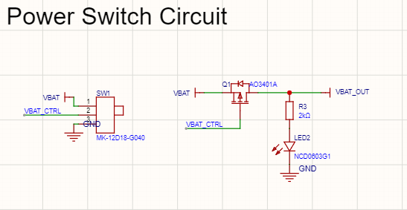

Week 2: Power Switch Circuit and Battery Load Management
1. Functional Overview
This schematic details the Power Switch Circuit, which acts as the primary hardware interlock for the robot's battery power. It combines a physical sliding switch (SW1) with a high-side P-Channel MOSFET (Q1) to control the flow of energy from the battery (VBAT) to the rest of the system (VBAT_OUT). This setup provides a reliable way to completely de-energize the robot's high-power components, such as the motors, while preventing unnecessary battery drain when the device is not in use.
2. Design Rationale
- High-Side P-Channel MOSFET Switch (Q1):
  - The AO3401A P-Channel MOSFET is the core switching element. It was selected for its low $R_{DS(ON)}$, which minimizes power loss and heat generation when the robot is drawing high current for motor maneuvers.
  - By using a MOSFET to handle the actual load current, the physical switch (SW1) only needs to handle a very small signal-level current to toggle the MOSFET's gate. This prevents the mechanical contacts of the switch from degrading due to the high inrush currents typical of DC motors.
- Control Logic (SW1):
  - SW1 (MK-12D18-G040) is a slide switch that controls the VBAT_CTRL line.
  - When the switch connects VBAT_CTRL to GND, the gate of Q1 is pulled low, turning the MOSFET "ON" and allowing power to flow to VBAT_OUT.
  - When switched to position 1, VBAT_CTRL is tied to VBAT, turning the MOSFET "OFF."
- Visual Status Indicator (LED2):
  - The NCD0603G1 LED, paired with a 2kΩ current-limiting resistor (R3), is connected directly to the VBAT_OUT rail.
  - This provides an immediate visual confirmation that the system is energized, serving as a critical safety feature for the user.
- Safety and Protection:
  - The circuit utilizes a common GND for all control signals to ensure logic stability.
  - The use of the AO3401A provides a degree of inherent protection against transient spikes from the motor rails during power-down cycles.
3. Expected Outcome
This power management strategy ensures that the robot can be safely turned on and off without risking mechanical wear on the primary control switch. The low resistance of the AO3401A ensures that the full potential of the battery is delivered to the TC118S motor drivers, enabling maximum torque and efficiency. Additionally, the integrated LED indicator provides a professional "power-on" feedback mechanism, improving the overall user experience and safety of the desktop robot.

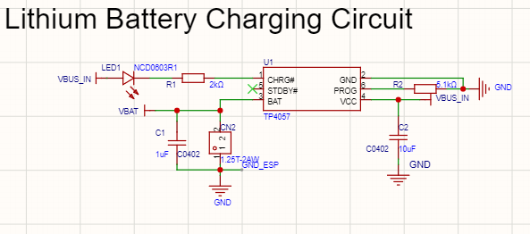

Week 2: Lithium Battery Charging Circuit
1. Functional Overview
This schematic illustrates the Lithium Battery Charging Circuit, centered around the TP4057 linear charger IC. This subsystem manages the safe replenishment of the robot's onboard lithium battery using power provided by the VBUS_IN (USB 5V) rail. It handles the entire charging profile—from trickle charge to constant current and constant voltage stages—ensuring the battery remains healthy and ready for autonomous "desk fatigue" combat maneuvers.
2. Design Rationale
- Charging IC Selection (TP4057):
  - The TP4057 was chosen for its simplicity, small SOT-23-6 footprint, and integrated thermal feedback, which prevents the IC from overheating during high-current charging cycles.
  - It requires no external sense resistor or blocking diode, saving valuable PCB real estate.
- Charge Current Programming:
  - The charging current is set by the PROG (Pin 6) resistor R2 (5.1kΩ).
  - Based on the TP4057 formula ($I_{bat} = (V_{prog} / R_{prog}) \times 1000$), a 5.1kΩ resistor sets a safe and efficient charging rate of approximately 200mA, suitable for the target battery capacity while minimizing heat.
- Visual Status Indicator (LED1):
  - The NCD0603R1 (Red LED) and R1 (2kΩ) are connected to the CHRG# (Pin 1) open-drain output.
  - This LED illuminates while the battery is actively charging and extinguishes once the charge cycle is complete, providing clear user feedback.
- Power and Stability:
  - C2 (10uF) and C1 (1uF) provide decoupling for the VCC and BAT pins, respectively. These capacitors suppress voltage ripples and ensure the charging control loop remains stable regardless of transients on the USB power line.
- Battery Interconnect (CN2):
  - A 1.25T-2AW connector is used for the physical battery connection (VBAT and GND). This ensures a secure, polarized attachment that prevents accidental reverse-polarity damage during assembly.
3. Expected Outcome
This charging circuit provides a reliable and autonomous power replenishment system for the robot. By utilizing the TP4057, the design guarantees that the lithium battery is never overcharged, significantly extending its operational lifespan. The integrated LED and standardized connector make the system user-friendly and easy to maintain, while the optimized 200mA charge rate ensures the robot can be fully recharged from a standard USB port in a reasonable timeframe without excessive thermal stress.

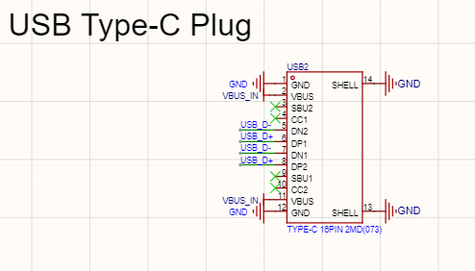
Week 2: USB Type-C Plug for Dedicated Charging Input
1. Functional Overview
This schematic section features a USB Type-C Plug (16-pin), which serves as the robot's dedicated power input port. Specifically designed for charging the onboard lithium battery, this interface accepts 5V from an external USB power source via the VBUS_IN lines. By utilizing the modern USB-C form factor, the robot benefits from a robust and reversible connection point for maintaining its energy reserves.
2. Design Rationale
- Charging-Centric Design: While the connector includes data pins, its primary implementation in this system is to provide a reliable path for VBUS_IN. This 5V supply is routed directly to the TP4057 charging circuit to replenish the battery, which then powers the high-current components like the TC118S motor drivers.
- Power Handling and Efficiency:
  - Pins 2 and 11 are tied to VBUS_IN. Doubling these pins allows the connector to handle charging currents with lower resistance, reducing heat generation during the charge cycle.
  - The symmetric layout ensures that the robot can be charged regardless of the cable's orientation, enhancing user convenience.
- Mechanical Durability: The SHELL pins (13, 14) are securely grounded. This provides critical mechanical reinforcement for the connector, ensuring it remains firmly attached to the PCB even after repeated insertion and removal of the charging cable.
- Signal Isolation: By isolating the charging input through this dedicated plug, the design ensures that high-power charging transients do not interfere with the internal communication or the PWM logic signals used to control the robot's movement.
3. Expected Outcome
The implementation of this USB-C plug ensures that the robot has a standardized and efficient method for battery charging. By dedicating this interface to power delivery, the design maintains a clear separation between charging operations and internal system logic. This setup guarantees that the robot remains ready for action, providing the necessary energy for the motors to combat "desk fatigue" while offering a professional, durable charging experience for the user.

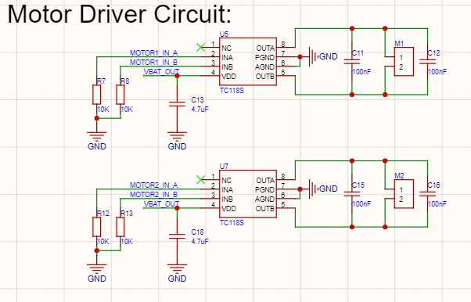

Week 2: Dual-Channel Motor Driver System
1. Functional Overview
This schematic section highlights the Dual Motor Driver Circuit, utilizing two TC118S H-bridge driver ICs to control the robot's locomotion. These drivers translate low-power PWM signals from the ESP32-S3 into high-current outputs required to drive the DC gear motors (M1 and M2). This configuration enables differential steering, allowing the robot to move forward, backward, and execute precise turns to interact with the user.
2. Design Rationale
- H-Bridge Driver (TC118S):
  - The TC118S is a single-channel integrated H-bridge driver designed for high efficiency and low voltage drops.
  - By using two independent ICs (U5 and U7), the design achieves full independent control over both wheels, which is essential for the robot's agility.
- Logic Protection and Stability:
  - Pull-down Resistors (R7, R8, R12, R13): $10\text{k}\Omega$ resistors are connected to the INA and INB inputs of each driver. These ensure the motors remain in a "High-Z" or coast state if the MCU pins are floating during boot-up, preventing unintended robot movement.
  - Input Filtering: C13 and C18 ($4.7\mu\text{F}$) capacitors are placed near the VDD pins to stabilize the VBAT_OUT supply, protecting the drivers from voltage dips caused by sudden current draws.
- Motor Noise Suppression:
  - C11, C12, C15, and C16 ($100\text{nF}$) are implemented across the motor terminals and to ground.
  - These capacitors filter out high-frequency electromagnetic interference (EMI) and brush noise generated by the DC motors. This is critical to prevent electrical noise from coupling into the sensitive I2S microphone or disrupting the LCD data signals.
- Power Efficiency: The drivers are powered by VBAT_OUT, which is the switched battery rail managed by the P-Channel MOSFET. This ensures that when the main power switch is off, the motor drivers are completely de-energized, preserving battery life.
3. Expected Outcome
The implementation of this dual-driver architecture provides a robust and responsive drivetrain for the desktop robot. The combination of hardware pull-downs and EMI filtering ensures that the robot's movement is predictable and does not interfere with its "face board" electronics. This system allows for the high-torque maneuvers necessary to effectively "combat" desk fatigue through expressive and dynamic physical motion.

